Technical Architecture:

Project Design Phase-II Technology Stack (Architecture & Stack)

|  |  |
| --- | --- |
| Date | 15 NOV 2022 |
| Team ID | PNT2022TMID29172 |
| Project Name | Project - Real-Time Communication System Powered by AI for Specially Abled |
| Maximum Marks | 4 Marks |

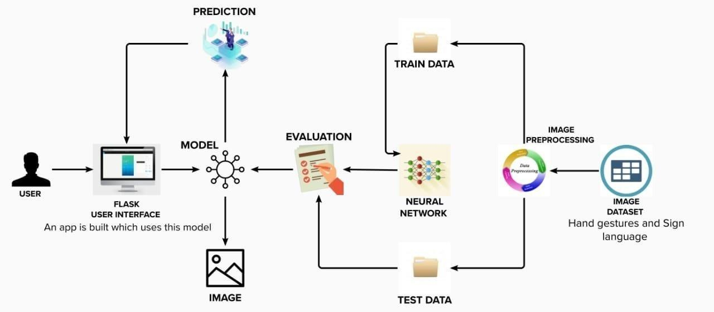

Table-1 : Components & Technologies:

|  |  |  |  |
| --- | --- | --- | --- |
| **S.No** | **Component** | **Description** | **Technology** |
| 1. | User Interface | The user interface is the point of human computer interaction and communication in a device. | Python flask |
| 2. | Flash UI | Flash User Interface components let you interact with the users that use your site and gather information. | It can be executed while using the cloud. |
| 3. | Models | Support Vector Machine (SVM) is subsequently applied to classify our gesture image dataset. | Machine Learning |
| 4. | Image Prediction | Gesture can be completely observable and viewing a gesture from another perspective  makes the prediction. | Artificial Neural Network (ANN), Convolution Neural Network (CNN) |
| 5. | Image | Image processing is used to made the image into signs by the neural network. | Artificial Neural Network (ANN),  Convolution Neural Network (CNN), Open CV |
| 6. | Speech | Speech translates the voice into image and sensitive neural play. | Artificial Intelligence and Machine  Learning methods like deep learning and neural networks. |
| 7. | Evaluate data | Aims to estimate the generalization accuracy  of a model on future data. | Natural Language Processing  (NLP) |
| 8. | Unstructured data | Unstructured data is a conglomeration of  many varied types of data that are stored in their native formats. | Natural Language Processing (NLP) |
| 9. | Structured data | Typically categorized as quantitative data is highly organized and easily decipherable  by machine learning algorithms. | Machine language and artificial intelligence tools. |
| 10. | Machine Learning Model | Based on Training. | Object Recognition Model, etc. |
| 11. | Dataset | First prototype of this system is was used a  dataset of 24 static signs from the Panamanian Manual Alphabet. | AI technology |

Table-2: Application Characteristics:

|  |  |  |  |
| --- | --- | --- | --- |
| **S.No** | **Characteristics** | **Description** | **Technology** |
| 1. | Open-Source Frameworks | Robots and other tools provide home-based  care and other assistance, allowing people with disabilities to live independently. | Artificial Intelligence like robots and software systems. |
| 2. | Security Implementations | Set the inclusion and exclusion criteria , Report the results in the survey. | Artificial Intelligence |
| 3. | Scalable Architecture | The improvement in the specially abled persons interaction with the environments. | Artificial Intelligence |
| 4. | Availability | Justify the availability of application. | Conferencing technology |
| 5. | Performance | Enables people with disabilities to step into a world where their difficulties are  understood and taken into account. | Natural Language Processing (NLP) |